**Brno University of Technology**

Faculty of Information Technology

Microprocessors and Embedded Systems

2018/2019

Project

**ARM-FITkit3: Application of Random Number Generator Accelerator (RNGA) module**

Goldschmidt Patrik (xgolds00)  
Tomáš Daniš (xdanis05) Brno, December th, 2018

Contents

1. Introduction 3

1.1. Problem description 3

1.2. Authors 3

1.3. Information resources 3

1.4. Model validity 4

2. Analysis of problem and used methods 4

2.1. Problem specification 4

2.1.1. Technical aspects 4

2.1.2. Economic aspects 7

2.1.3. Environmental aspects 8

2.2. Used methodologies and technologies 9

3. Model concepts 9

3.1. Abstract model description 9

3.2. Abstract model representation 10

3.3. Implementation discussion 10

4. Simulation model architecture 11

5. Experiments 11

6. Conclusion 11

7. Bibliography 11

# Introduction

## Problem description

Simulation study described in this document analyzes long-term problem with taxis in Nové Zámky, small city in south of Slovakia. Nové Zámky is an important railway node which serves many trains per day. It is not as utilized as before for cargo shipping, but travelling by train is regaining its popularity and thousands of people use this kind of transport for their daily needs. There are two small parking lots for taxis located in front the station, where up to eight taxis are usually stationed. Upon train arrival, people exit the station and usually head for their parked cars, some of them take taxi or go by feet. During the peak times, most of the taxis are typically booked and leave the station with the client. However, capacity of the taxis is frequently insufficient during bigger bursts and potential customers have to wait for another taxi or leave by other means. On the other hand, numerous situations when lot of taxis are not booked for several hours also occurs.

Shortcomings of situation depicted above are rather clear. Current business model is ineffective and customers are often annoyed because they have to wait several minutes for another taxi to arrive. This situation is observed by authors of this study for past several years without a change. In this paper, we try to simulate current situation with taxis and present our own business model which helps to keep more clients satisfied and gain maximum possible revenue.

## Authors

Authors of this study are two students of Faculty of Information Technology at Brno University of technology, Czech Republic. Both of the authors know themselves for years and have co-worked on other projects also outside of the academic sphere.

About the authors:

* *Patrik Goldschmidt* – born in Nové Zámky, Slovakia. Keen on computer networking, computer security and Linux operating systems. Currently part-time employed as an assistant researcher at Department of Computer Systems, FIT BUT under the CESNET organization wing.
* *Tomáš Daniš* – born in Šala, Slovakia. Artificial intelligence, computer graphics and mathematics enthusiast. Holder of industry certifications CCNA & CNNP Route. Former employee of ARTIN.

## Information resources

For the purpose of this study, we tried to contact two owners of a taxi companies in Nové Zámky. One of them refused meeting without a reason, the second somehow misunderstood our intentions and eventually kicked as out without providing any information. We also tried to speak directly with the taxi drivers, who eventually got angry, sometimes even hostile when we asked them about their job.

According to this outcoming, described simulation study is based purely upon information found on Internet, as well as observations and personal experience gained during past years. All used sources are cited and can be found in the bibliography section.

## Model validity

Unfortunately, our initial intention to study current business model of one of the companies was not realizable. However, we decided to create completely new business model that will fill in the gaps found in the models of other taxi companies. Our new aim is to design a hypothetical competition that could potentially create a serious threat for current taxi companies.

Based on the situation, validity [1] of our created model may be questionable. We tried to gather as much data as possible, from weather conditions in the city throughout the year to exact fuel economy and car maintenance expenses of our hypothetical taxis. Gathered data used in simulations try to describe given situation in remarkable precision, but some data needed to be inferred according to our knowledge and predictions, because they were not publicly available. Due to complexity and number of different factors affecting the final model, mathematical proof is also impracticable.

To sum it up, we do not guarantee model validity and will let the reader to decide. Creating a valid model of this complexity with limited amount of data would prove difficult task in general. However, gathered and processed data should provide relatively close approximations to real-world situation and received simulation results should prove as valuable findings. All gathered or inferred data are described later in this document.

# Analysis of problem and used methods

## Problem specification

As mentioned in previous sections, our task will be to analyze current situation and create a business model that may be able to create competition for the present taxi companies. To achieve these goals, several factors including technical, economic and environmental aspects have to be taken into the account. These will be described more closely in upcoming subsections. Our aim will be to simulate regular working day, which is most common and extracting data from it will bring the most information.

### Technical aspects

Technical aspects of the model include:

* Information about trains
* Competition taxi vehicles and their placement

Most important aspect of the of the model is information about trains. More precisely, we need to know train timetables and their utilization, so taxis will be placed during peaks on other lucrative parts of the day, where lot of trains are arriving. For the purpose of this experiment, we will monitor only incoming trains, so our vehicles will be available for passengers that would like to use taxi services. Since we are not currently planning to do city pick up service or provide services by telephone, our taxis will stay parked near the train station. Because of this, outgoing trains are not important and so are not monitored.

According to the official document [2], there will be 52 trains arriving into Nové Zámky Main train station since 9.12.2018. 18 of these trains are international EuroCity trains, 7 of them are express trains and the rest are regular trains. To model system accurately, we need to determine how many people get off these trains in Nové Zámky station. Unfortunately, no such statistic is available for the public. However, according to article from February 2018 [3], 4128 people bought a ticket in Nové Zámky station averagely per day in 2017. This is not exactly information we were looking for, because this number represents only people who bought the ticket on place, not the ones who bought it online or from train conductor. We assume this number has risen a from the last year, but the statistics represent people who leave the station, not those who come into it. According to our knowledge and observation over the years, much more people travel from the city into their work than into the city. Also, students and other workers who come home only for a weekend and do not come back whole week also alter this statistic. With all aspects taken into account, we decided that average people getting off the train in Nové Zámky will be 4200.

Now, when we inferred the value of passengers travelling to the city, we have to distribute the value among to the trains. For the purpose of this simulation, trains are distributed into 2 categories – express trains and regular trains. Since half of all trains arriving to city are expresses and ECs, which are also fairly more used, ratio of train usage was set to the following values:

|  |  |
| --- | --- |
| **Type of the train** | **Passengers ratio** |
| Regular | 45% |
| Express & EuroCity | 55% |

Table 1: Passengers distribution between type of trains

After determining the ratio, we need to divide passengers of regular trains according to the part of the day. Most people will travel in early morning to work and in early evening from work. That brings us 5 main parts of the day: Early bird, Morning Peak, Day attenuation, Evening Peak, Late-evening attenuation and Night stagnation. To properly distribute people in these parts, train schedule has to be analyzed more closely. There are gaps in which the train do not come at all. Most common pattern is a 10m train arrivals. For simplification purposes, we distribute passengers from regular trains by into 10m blocks, each representing a single train and carrying certain number of passengers.

|  |  |  |  |  |
| --- | --- | --- | --- | --- |
| **Part of the day** | **Start** | **End** | **Time block [min]** | **Passenger ratio** |
| Early bird | 04:00 | 05:40 | 10 | 0.07 |
| Morning peak | 06:00 | 09:10 | 10 | 0.20 |
| Daily attenuation | 10:00 | 16:10 | 10 | 0.12 |
| Evening peak | 16:30 | 19:10 | 10 | 0.46 |
| Late-evening attenuation | 19:30 | 21:10 | 10 | 0.09 |
| Night stagnation | 21:20 | 00:40 | 30 | 0.06 |

Table 2: Parts of the day and their passenger ratio

Table 2 illustrates 5 parts of the day, each with ratio which corresponds to number of passengers who get off the train in this time. This value was gained by observation and logical thinking. As we can see, most people come in the evening, when they are getting back from work. In the morning however, spike is not so big because people do not work in the city as there is a rather big lack of work. Most of the morning peak is composed of students coming to school.

Distributing Express and EuroCity trains can not be done by time blocks, because gaps between trains are too big, and these types of trains are supposed to simulate bursts as well. Each of the Express/EuroCity is then independent object with its own ratio assigned to it by observation.

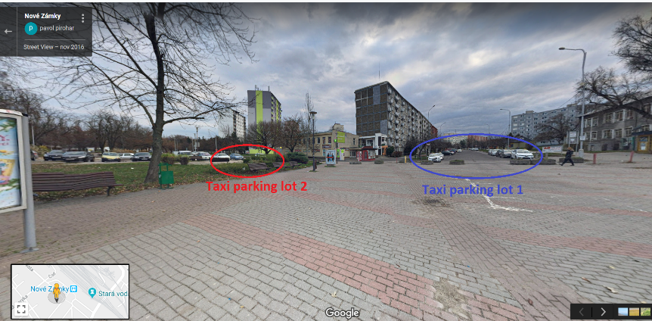 Another important aspect is number and distribution of another taxis, which will pose as a competition in this simulation. Parking and waiting are possible in one of the 2 places shown in the figure 1. Each of this place is occupied by different number of taxis in different times. According to knowledge and long-time experience, parking lot 1 has up to 10 parking slots, which is usually filled by 4-5 taxis during the day, 6-7 during peaks and 0-1 vehicles in the night. Parking lot 2 contains up to 4 taxis, but is generally occupied only with 1-2 taxis.

Figure 1: Taxi vehicles parking locations

Parking lot 1 works in the form of queue, where passengers almost always choose the taxi in the first row. After the taxi is booked and it leaves, other taxis shift and another taxi replaces the one which just left. On the other hand, parking lot 2 has rather “random” access, where taxis stand beside each other and client chooses one random, which then takes him to the desired location.

When people leave the train, most of them heads towards their cars in the parking lot. According to our observation on 03.12.2018, from 16:00 to 18:00, approximately 10% of the people take the taxi, around 55% head for their cars, 21% waits for their own transport and the rest leave by feet. These statistics were obtained from the total of 519 people, who were observed by authors of this study. Temperature on this day was 3° C, weather was cloudy with slow wind. This statistic would probably differ from the one that would be collected during the spring/summer days, when people are more likely to leave the station by feet. According to our sources, difference between weather situation does not have that great impact on the taxi usage than we initially expected. When the weather is bad, approximately 23% of the people take the taxi, which is a rise by 11%. For a discussion about weather, see section 2.1.3.

After the taxi is booked, it leaves the parking lot and go takes client to desired location. According to personal experience and google maps, typical ride to the city takes up to 7 minutes, whereas a ride to city outskirts takes up to 10 minutes. These times can rise up 150% during peak times, because some parts of city are not designed to handle huge volumes of traffic.

### Economic aspects

Since one of the main products of the simulation study is a realistic business model, economical aspects have to be studied and applied with special care. Initial costs of the creating new company (5000€ + 30€) as well as obtaining a car suitable for these purposes will not be included. Goal of the study is to provide information about business model sustainability. Considering a new car – Škoda Octavia 2019 1.6 TDI/85 kW used in this simulation, initial costs for purchasing it in Ambition version would be about 22 000€ [4]. Intuitively, these costs would cause initial investment to be highly unprofitable. However, we may calculate time needed to cover up these investments in conclusion section. Maybe we will be pleasantly surprised.

One of the most important economical aspect are expenses for the fuel. Our chosen car Škoda Octavia has a diesel motor with average fuel consumption of 4.6l/100km in the city [5]. Based on the [6] sources from official Statistics authority in Slovakia, average price of diesel was 1.292€ per liter.

Another expense needed to be taken into the account is car maintenance. This comprises costs for tires, filters, oil and car washing service. Generally speaking, tires lasts up to 2 years, filters and oil will need at least 2 changes per year (since we expect taxi vehicle to be heavily used every day) and car will need to be washed every week, which makes up to 52 washes per year. For business purposes, 20% of the tax may be stripped from the total costs from all items except carwashing. Detailed expenses for taxi vehicle maintenance may be seen in the table 3.

|  |  |  |  |
| --- | --- | --- | --- |
| **Expense** | **Unit cost** | **Cost per year** | **Cost without tax** |
| Summer tires | 4 x 50€ | 100€ | 80€ |
| Winter tires | 4 x 50€ | 100€ | 80€ |
| Oil + filters | 100€ | 200€ | 160€ |
| Carwash service | 7.50€ | 390€ | 390€ |
| **Total** |  | **790€** | **710€** |

Table 3: Annual yearly expenses for taxi vehicle

To place our taxis into the system, one of 2 parking lots depicted in figure 1 needs to be chosen. Parking lot 1 provides better chance for customers too see the taxi, so most of the customers are likely choose taxi parked rather than on parking lot 2. However, our taxis would need to rent the parking place to stay here, thus needed to pay monthly rent. We did not obtain official price for the place, but according to our sources, payment of 400€ per month is billed. On the other hand, parking on parking lot 2 is free at the cost of lesser chance for the customer to pick a taxi here. Our future simulations will try to find out which of these places provides higher revenue.

To make list of the expenses complete, we need to find out an employee and pay him a monthly wage. According to our research on job portals between 06.12.2018 and 09.12.2018, taxi driver jobs in nearby locations offered from salary from 650€ to 800€. Most similar offer with shown salary was found from competition company Elpo taxi s.r.o. found on the careerjet.sk, offering 800€/month. To find a proper driver who will be willing to work for our company, we need to match these salary offers, so driver will not deflect to another company. Monthly expense on salary of 800€ will then be considered. Another way to calculate expense is by paying a driver per-hour, which would mean 5€/h to keep up the 800€ salary as stated above.

Costs of our rides will also need to be adapted to the current prices in Nové Zámky city. Most commonly used price is 2€ per city ride and 3€ per city outskirts ride [7]. To make model simpler, our business plan and simulation model will not consider providing rides to nearby villages, which have variable prices according to their distance.

### Environmental aspects

Environmental aspects are very important for validity of the model, since people are much more likely to take a taxi when the weather is bad. Bad weather feeling is relative and it varies from person to person, thus we need to define what “bad weather” really is and how it affects regular customer behavior. From this moment, “bad weather” will be referred as a weather, when its either raining or freezing. Rainy day will be defined as a day with 2 mm or more rainfall.

[8] provides comprehensive climate statistics for Nové Zámky city and states that there are 91 days when it is freezing and 126 days when rain activity is detected. Filtering out the days with less than 2mm rainfall and statistically computing which days are rainy and freezing at once, we obtain 140 “bad days” in total. Computing probability of a bad day by 140/365, formula to statistically compute if a next day will good or bad is defined.

## Used methodologies and technologies

Abstract model was created using queuing theory concepts. Firstly, model description was transferred into more formal description, which was later converted into Petri net. This model was used as a foundation to create simulation model in the SIMLIB library, which allows to create models directly in C++ language by providing simulation abstraction and tools [9].

Technologies:

* C++14
* SIMLIB 3.07

# Model concepts

## Abstract model description

According to the collected data described in previous chapter, following verbal model description was formulated:

When a train arrives into Nové Zámky rail station, people get off it and most of them head for the exit. After existing the train, 12% of the people try to take the taxi, the rest leaves by other means. If the weather is bad, number of people willing to take the taxi rises up to 23%. People seeking the taxi choose one of two taxi parking stations and head to it. Chance of choosing first parking lot is 70%, whereas 30% of the people head to parking lot 2. If one of the parking lots has no taxis, people look to the other one. If there are no taxis in both parking lots, customers enter the queue with the probability of 72%. Others leave the system. When the customer is in queue, he waits for 14 minutes with exponential distribution and then leaves, if no free taxi which can serve him arrive in that time. If the weather is bad, 94% enters the queue and wait there for exponential 35 minutes. When the customer successfully books a taxi, 92% go to the city and leave the system after exponential 6 minutes. The rest desire a city outskirt ride, which takes exponential 8 minutes.

Description above depicted behavior of the typical passenger arriving to Nové Zámky station. For the business model purpose, we are going to place one or more taxis to the parking lots and monitor them to obtain statistics about utilization and possible earnings.

Collected data described in the previous chapter were tailored especially for this simulation model, so almost no alteration of the data was needed prior to creating the abstraction model description.

Passengers are generated using various generation events representing arriving trains. Trains arrive according to official timetable defined by [2]. Generator spawns number of passengers defined by the part of the day, as stated in 2.1.1. Directly after spawning, passenger process begins to perform process defined in the upper part of this section.

## Abstract model representation

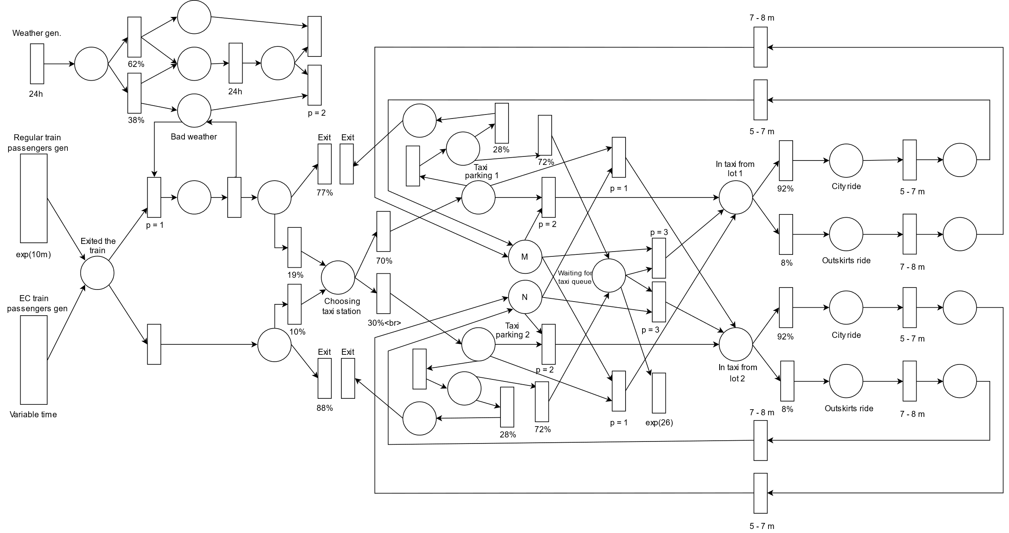 According to the description in the previous section, abstract model represented by Petri net was created. This model is depicted in the figure 2.

Figure 2: Petri scheme of the model

Presented Petri net is a simplified version of the queue. In the description and in our simulation model, weather has effect on a chance to enter the queue as well as on the time that the client spends in the queue. This was omitted from the Petri scheme to make it more readable.

# Architecture of simulation model

## Architecture description

Whole simulation process is represented by Simulation class, which holds all necessities needed for the simulation itself and also provides an interface to control the simulation. Simulation object is wrapped by Experiment class, which provides an easy way to perform various experiments by providing an experiment configuration file. Configuration files describe experiment by specifying simulation parameters. More about the simulation configuration files can be read in section 4.2.

Whole program is run by passing an experiment configuration file as a parameter. This parameter is parsed by the main() function and furthermore used to create Experiment class instance. New experiment object parses the specified experiment file and setups the simulation. Main file then calls Run() method of the experiment object, which creates the simulation class instance and runs the simulation. After the simulation ends, simulation object dumpStats() method is called, which causes creation of the statistics file and dumping its computed data into it.

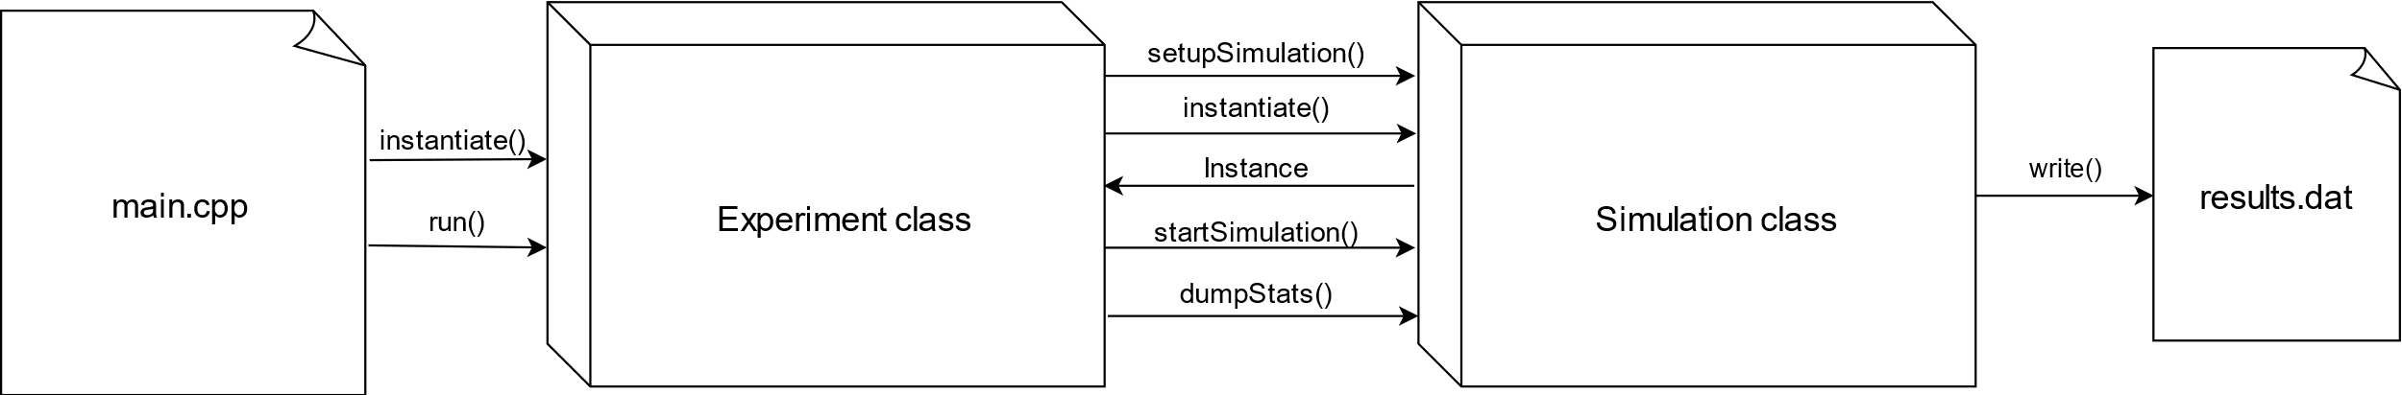Figure 3: High-level implementation architecture

## Parametrizing experiments

Simulation program allows specifying own experiments via experiment configuration files. Experiment configuration file specify parameters of the experiment and is use to run the simulation program. This file is passed to the simulation program as its first parameter. Mandatory structure of the simulation file is defined as follows:

Output: <outputfile>

Simdays: <Number of days to simulate>

PL1: <Number of taxis on the parking lot 1>

PL2: <Number of taxis on the parking lot 2>

Output field specifies a name of the output file. Simdays represents number of days to simulate. PL1 is a tuple consisting of 6 numbers specifying number of taxis to stand on the parking lot 1. PL2 has the same function as PL1, but specifies number of taxis on parking lot 2.

Example of an experiment file:

Output: exp1.out

Simdays: 365

PL1: 1 3 0 3 2 0

PL2: 1 1 1 1 1 1

This file specifies a experiment, which will run for 365 simulation days, have 1 taxi at early bird’s part of the day, 3 taxis during morning peak, 3 taxis during evening peak and 2 taxis during late-evening attenuation which will be parked on parking lot 1. There is also 1 taxi parked at parking lot 2 for the whole day.

Simulation program is then run with the experiment configuration file in the following style:

./ims_proj config_file.ecfg

# Experiments

## Approach and goals

As outlined in the previous sections, goal of the experiments is to create a valid business model that would solve the bad taxi situation in Nové Zámky and also be profitable for its authors. Firstly, we will simulate a approximation of current business model of competition taxi companies, so our taxis will not be used during the simulation. According to the result received in this section, we will decide how many taxis should be used and in which parts of the day they should be active. Other experiments will try to uncover more information about the model and try to maximize profits and serve as many clients as possible.

## Details

### Experiment 1 – Exploring the current business model

### Experiment 2 – Adding own taxis

Based on our findings from the exploration of the current model, we have decided to try adding our own taxis to the system in order to serve the customers for which the current capacities were not sufficient and had to wait or find another means of transportation. In the model, we added our own taxi to parking lot 1 during the busiest periods of the day – the morning and evening peaks. Unfortunately, the demand has shown not to be enough, and our income was erased by the maintenance costs and fees. This can be seen in the following figure:

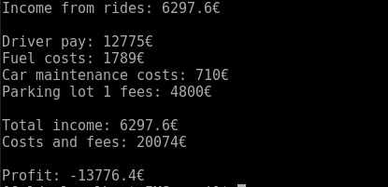

As is evident from the figure, with this model, we would experience heavy losses and would not be able to survive long. However, there are ways we can improve our profits as demonstrated in subsequent experiments.

### Experiment 3 – Optimizing the revenues

In this experiment, we based our decision based on the result of Experiment 2. One of the observations we made was that we were paying almost 5000 Euro in fees for a space in parking lot 1. While more customers go to parking lot 1, it is more expensive and there are more competitors. Therefore, we have decided to try to relocate to parking lot 2 with operating times remaining the same as in Experiment 2 – during the morning and evening peaks. The results of the experiment can be seen on the following figure: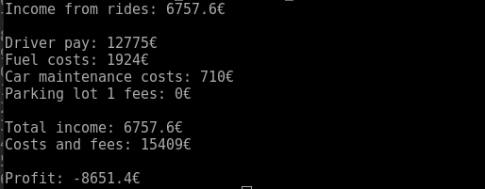

As we can see, the change of parking lots helped, but was not sufficient. We are 5000 euro less in loss due to not having to pay parking lot 1 fees. The aspect of lesser competition we thought relevant was shown to be unimportant.

### Experiment 4 – Driving our own taxi

Based on the data from Experiment 3, we can notice that the greatest drain of money is driver fees. Therefore, we have decided to simulate what would happen if we were to drive our own taxi instead of paying a driver. We believe this should put the profit number into the positives. The result of the experiment can be observed here: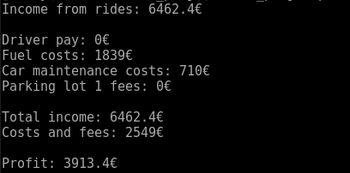

We can see that we have managed to make some money. However, the length of the simulation was one year. It is not sufficient to make 4000 euro during one year.

## Results

From a series of experiments, we have concluded that it is not prospective to open your own Taxi company in Nové Zámky.

# Conclusion

This simulation study analyzed taxi situation related to Main train station in Slovak city Nové Zámky. Our experiments have revealed that ...

# Bibliography

[1] PERINGER P. & HRUBÝ M. *Modelling and simulation (slide 37).* September 2017. Brno University of Technology

[2] ŽELEZNICE SLOVENSKEJ REPUBLIKY. *Príchody do Nových Zámkov*. November 2018. Retrieved on 09.12.2018. Available at:  
<http://www.novezamky.sk/assets/File.ashx?id_org=700036&id_dokumenty=30188>

[3] NOVÉ ZÁMKY 24. *Každé ráno cestujú za prácou a školou tisíce Zámčanov: Koľko z nich volí vlak?*. February 2018. Retrieved on 09.12.2018. Available at:  
<https://novezamky.dnes24.sk/kazde-rano-cestuju-za-pracou-a-skolou-tisice-zamcanov-kolko-z-nich-voli-vlak-291068>

[4] ŠKODA OCTAVIA ČESKÁ REPUBLIKA. Škoda Octavia 2019 cenník. Retrieved on 09.12.2018. Available at:  
<https://az749841.vo.msecnd.net/sitescscz/alv1/d71398f7-bee2-492b-a678-5bfc6de901f8/cenik-octavia%202018-10-19.8767b4708d6fb689efd8d0285cd6875d.pdf>

[5] ŠKODA OCTAVIA ČESKÁ REPUBLIKA. Nová Škoda Octavia. Retrieved on 09.12.2018. Available at:  
<https://az749841.vo.msecnd.net/sitescscz/alv1/2586e3e7-1197-4d31-a1f0-2f1020ef22b9/octavia-katalog.561c73c974bb5df115ffde03eeed2c57.pdf>

[6] BENZIN.SK. *Priemerné ceny PHM k 09.09.2018*. Retrieved on: 09.12.2018. Available at: <http://www.benzin.sk/>

[7] ELPO TAXI. *Naše ceny*. 01.09.2017. Retrieved on 09.12.2018. Available at: <http://www.elpotaxi.sk/prices.php>

[8] METEOBLUE. *Podnebie Nové Zámky*. Retrieved on 09.12.2018. Available at:  
<https://www.meteoblue.com/sk/počasie/predpoveď/modelclimate/nové-zámky_slovenská-republika_3058472>

[9] PERINGER P. *SIMLIB Simulation library*. Retrieved on 09.12.2018. Available at: <http://www.fit.vutbr.cz/~peringer/SIMLIB/>